Creating cloud machine with different Ubuntu Images

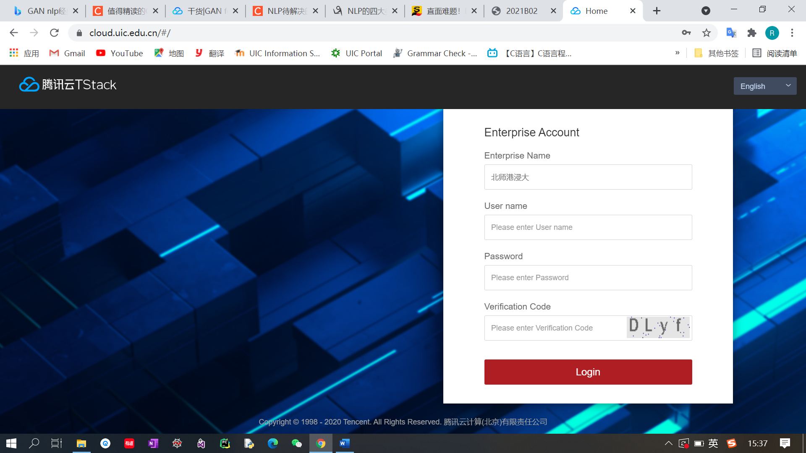

1. Go to the cloud.uic.edu.cn and log in with identity.

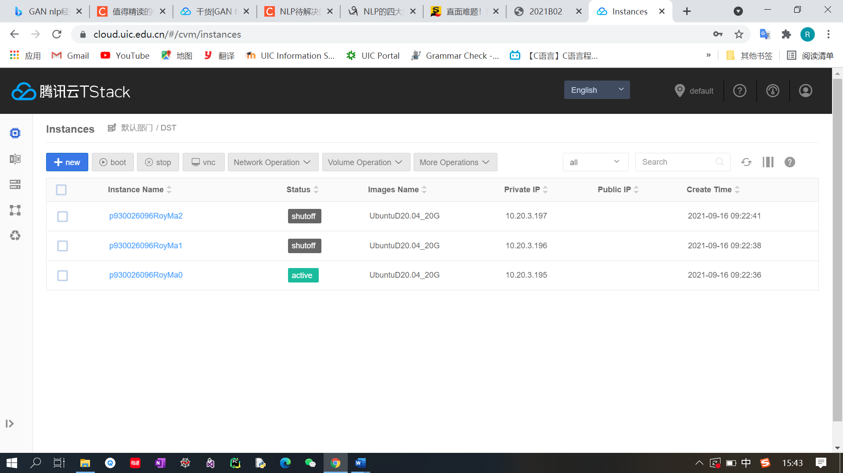

1. Click ‘+new’ in the top bar to create a new cloud machine.

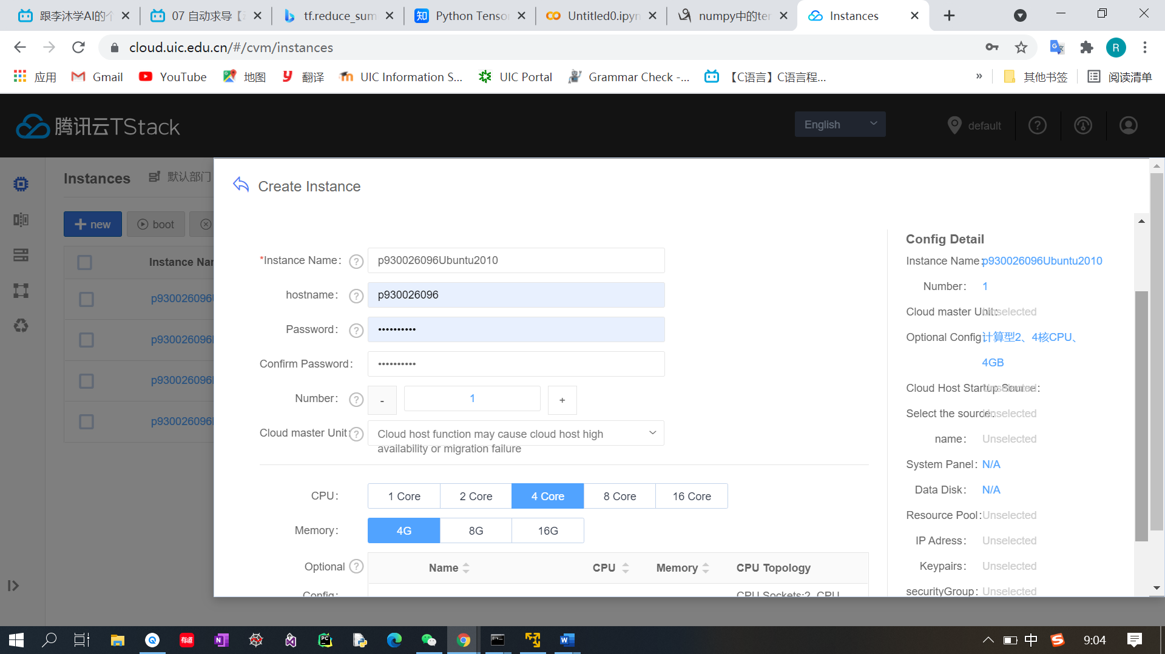

3.Fill in the password and choose the CPU and memory

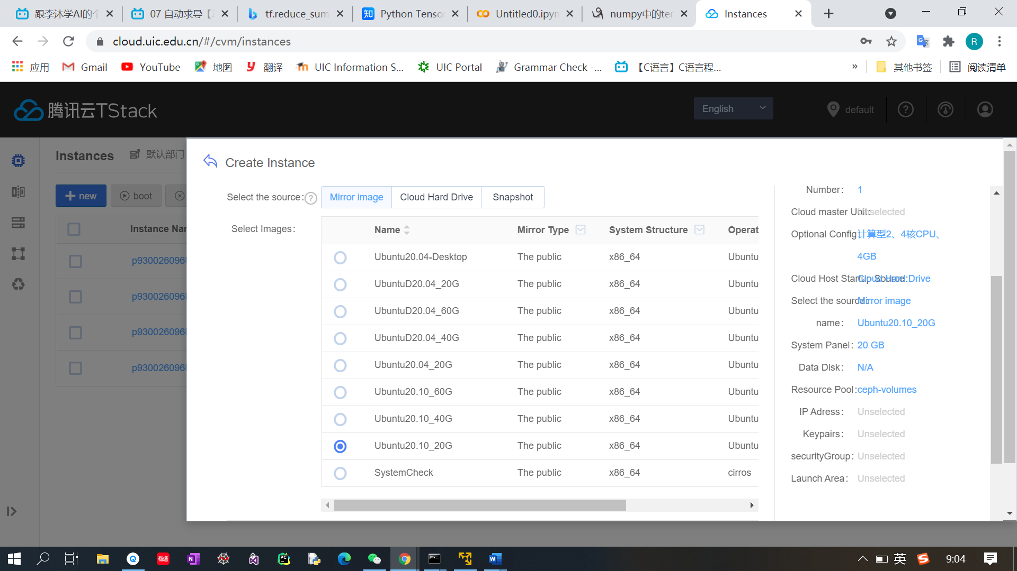

1. Choose any images which is different from the above screenshot. For example, choose the Ubuntu18.04_20G. And click ‘Next step’.

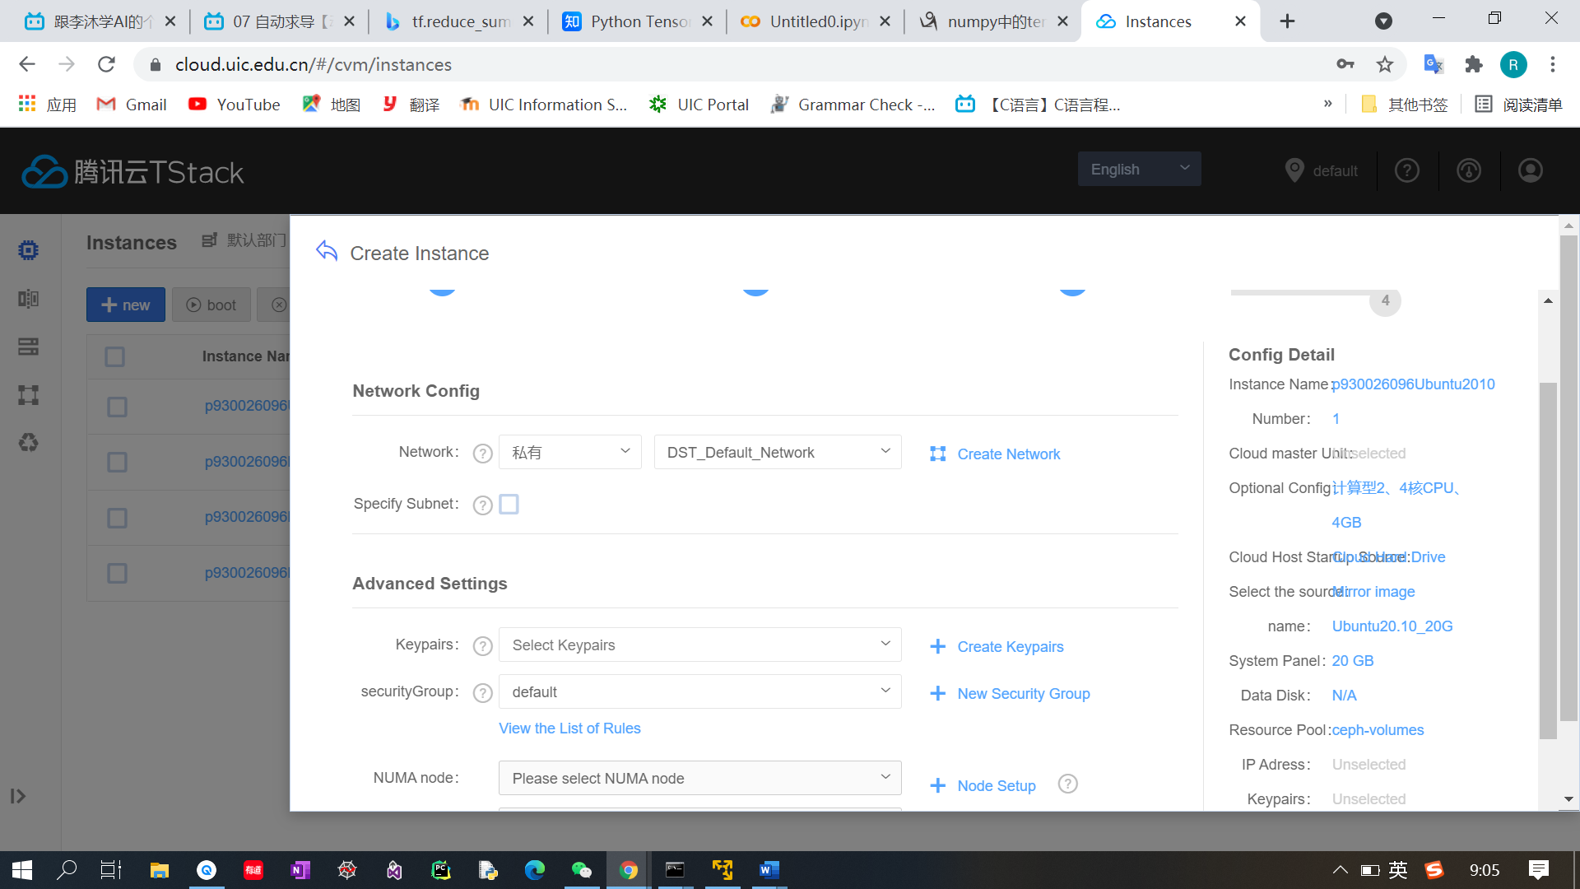

1. All default settings and click “Next step”.

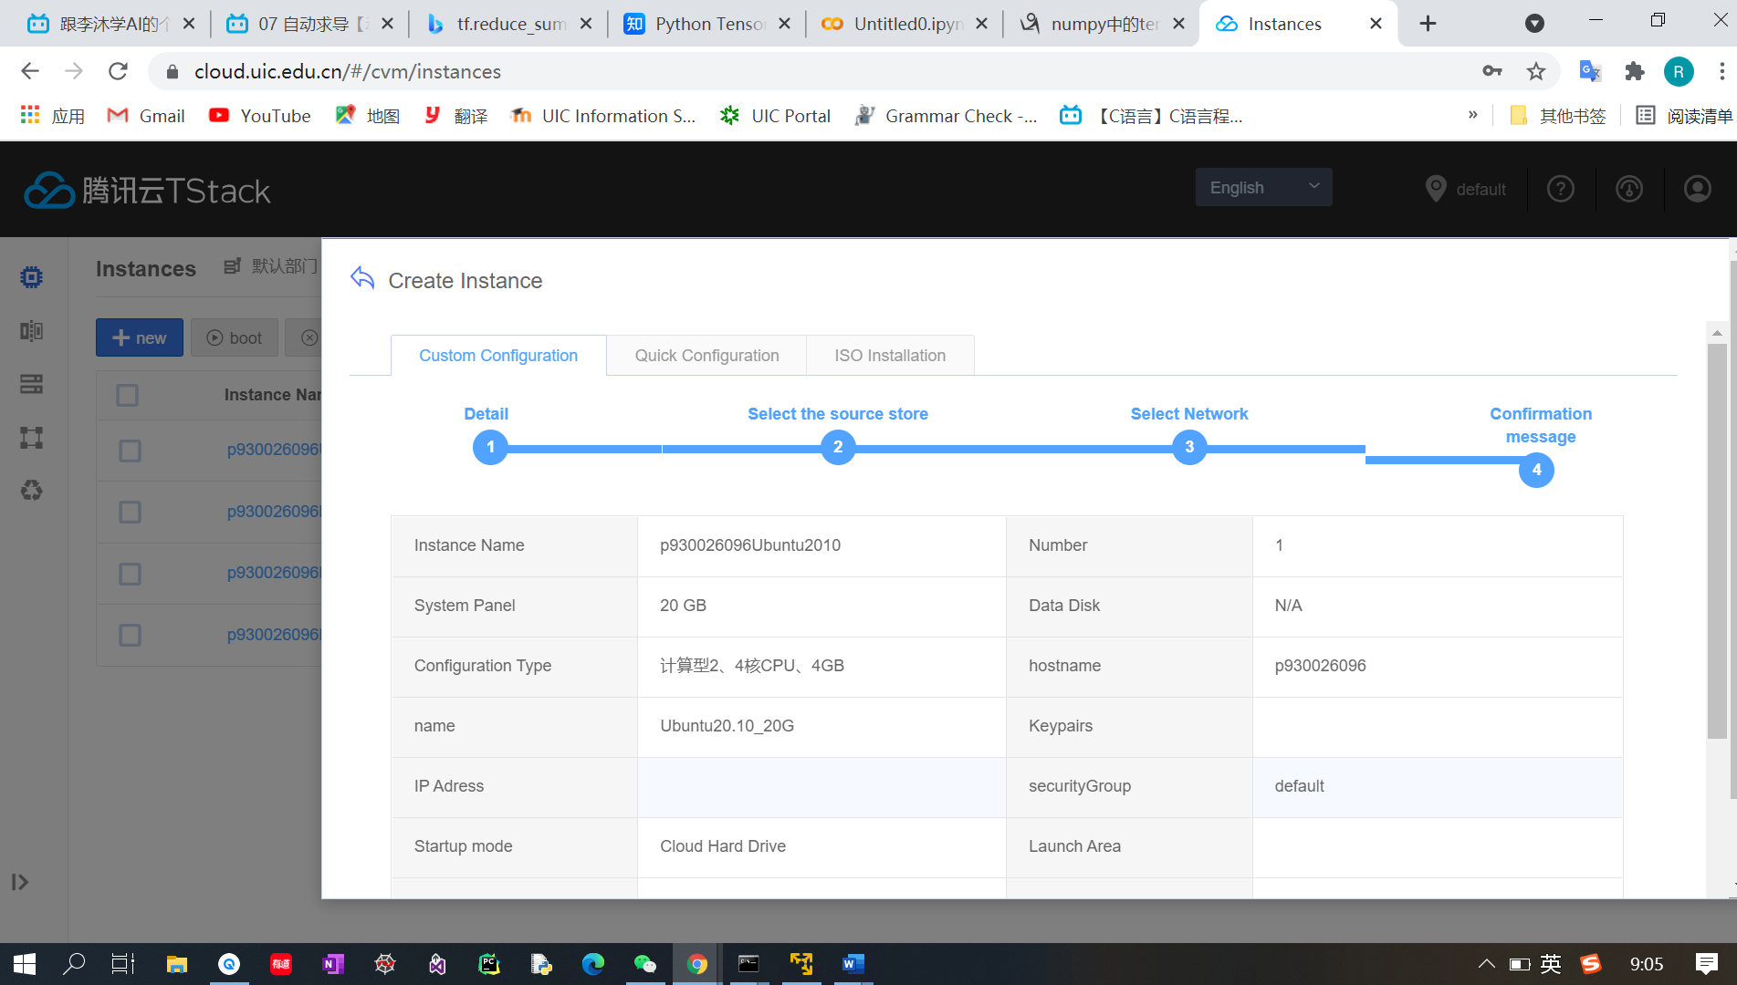

1. View all the setting of your new cloud machine and if everything is OK, then click “create instance”.

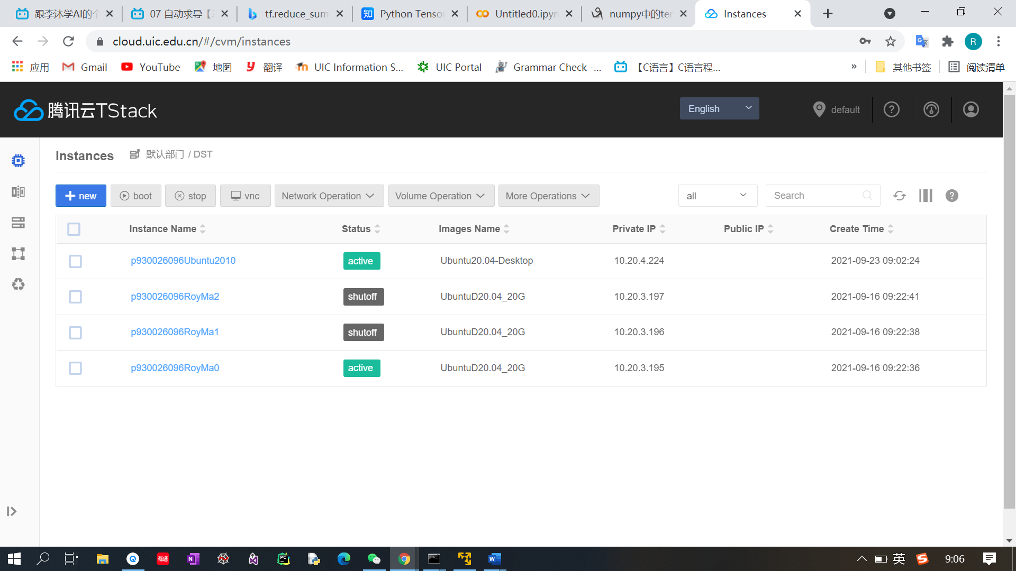

1. Wait 1-2 minutes until the new cloud machine status turns to active.

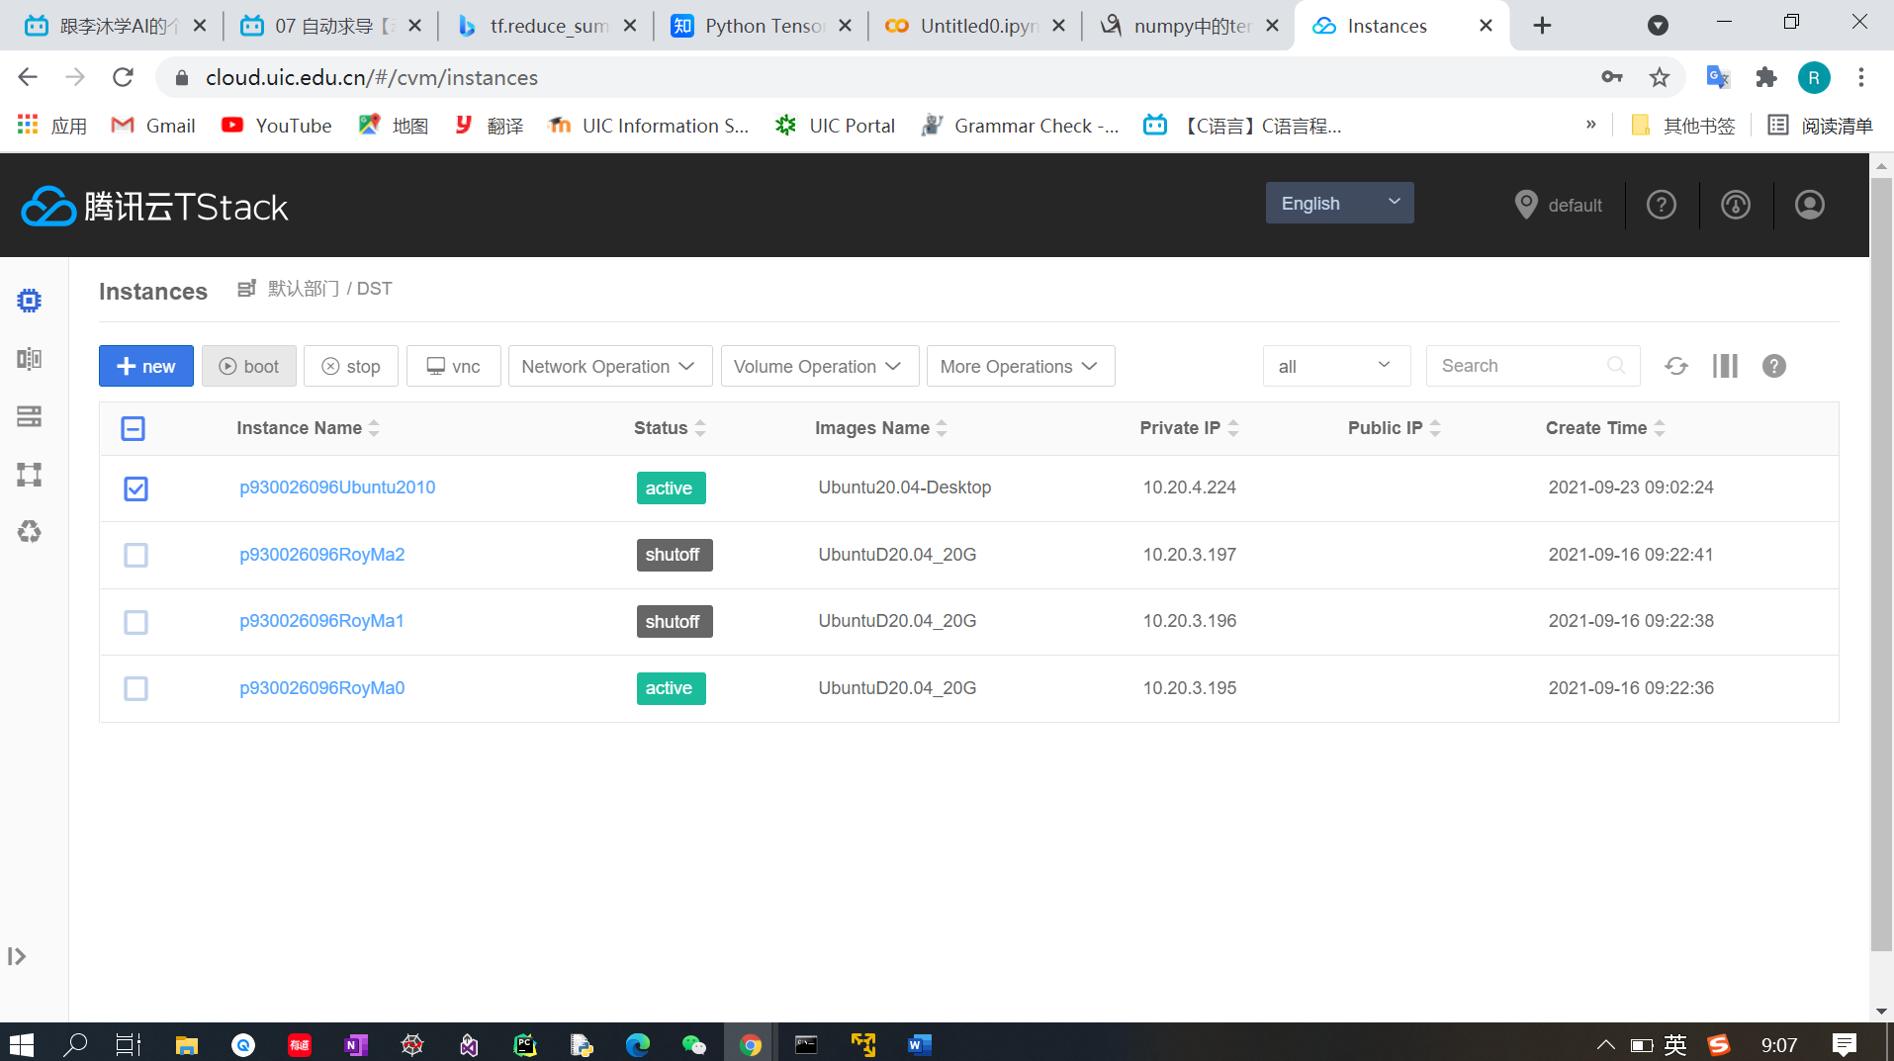

1. Choose the instance: p930026096Ubuntu2010 and click vnc to build up connections.

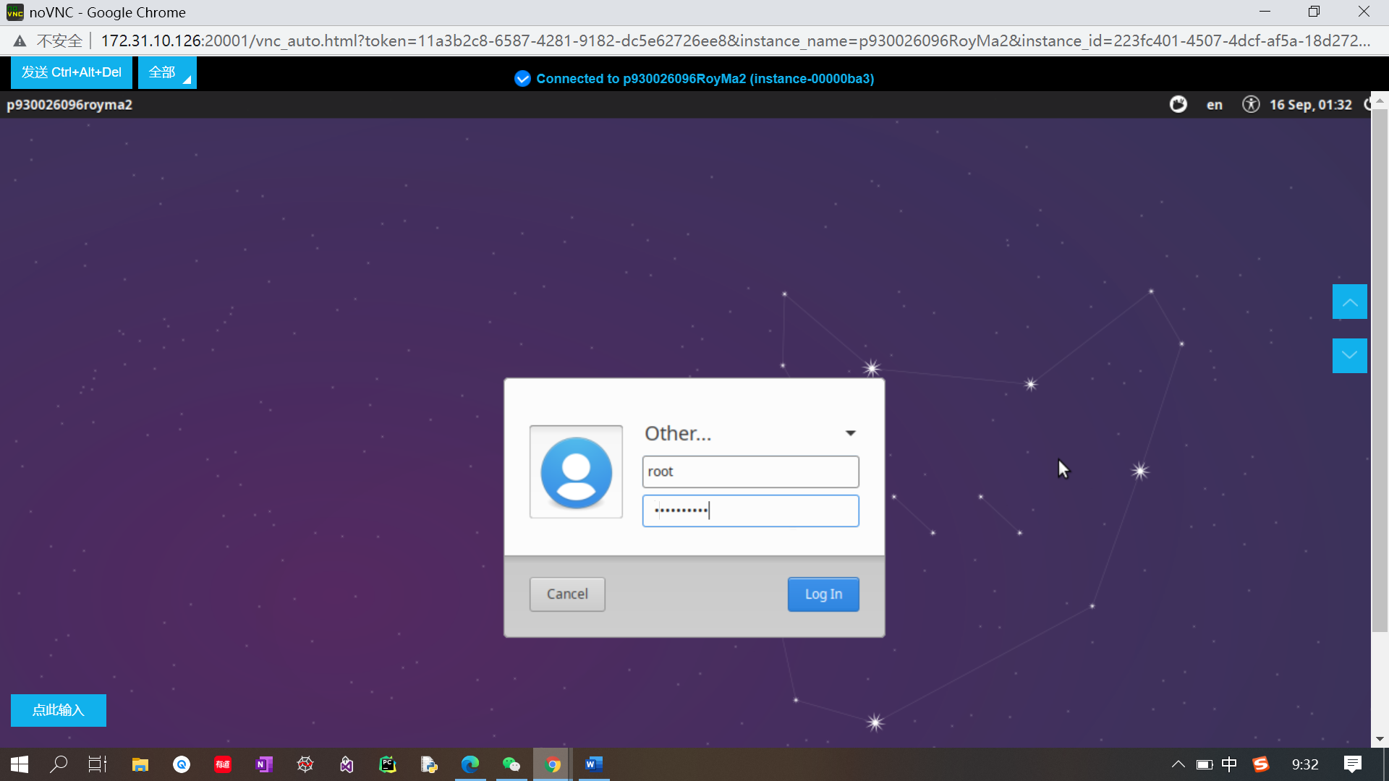

1. Choose other and enter name root, and password.

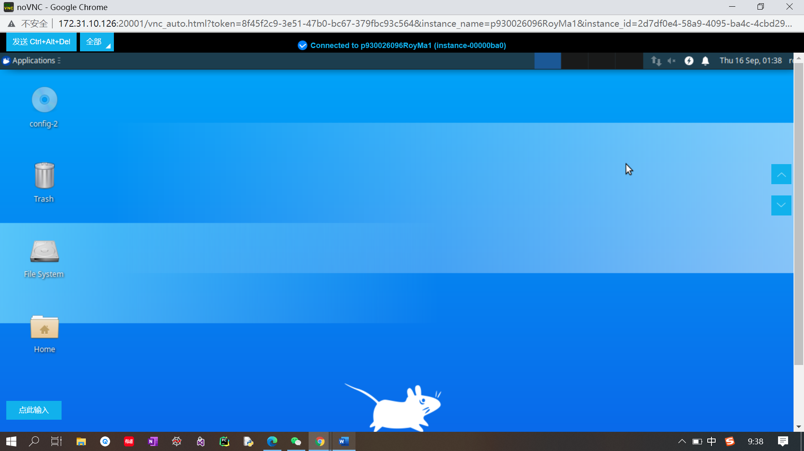

1. After click the log in, we will enter a user interface looks like the above screenshot.